sUPPLY CHAIN – EXPRESSION OF INTEREST BRIEF
NZT NEP OSBL Project

CIVILS (ENABLING)

EXPRESSION OF INTEREST BRIEF

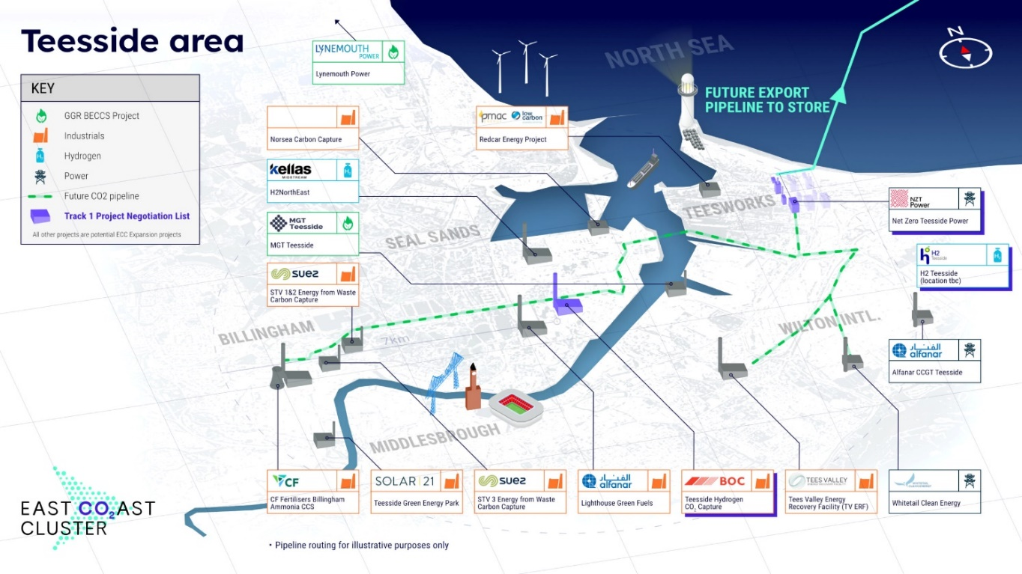
EX
Contents
2 Abbreviations 2
2.1 Abbreviations 2
3 Introduction 3
3.1 Purpose of this Document 3
4 Project Overview 4
4.1 Project Background 4
5 Project Scope 5
5.1 OSBL Scope of Work 5
5.2 Programme 7
6 Facilities Contract Strategy 8
6.1 Procurement Drivers 8
6.2 Procurement Process 8
6.3 Confirmation if Interest 8
7 EXPRESSION OF INTEREST - RETURN 9
8 SUPPLY CHAIN QUESTIONNAIRE 10

Abbreviations

Abbreviations

Term | Definition
AGI | Above Ground Installation
CO2 | Carbon Dioxide
ECC | East Coast Cluster
EPCC | Engineering, Procurement, Construction and Commissioning
EPCM | Engineering Procurement and Construction Management
EOI | Expression of Interest
F&G | Fire And Gas
FEED | Front End Engineering Design
FID | Final Investment Decision
FOAK | First of a Kind
HV | High Voltage
ICSS | Integrated Control and Safety System
IJV | Incorporated Joint Venture
ISBL | Inside Battery Limit
KV | Kilovolt
KM | Kilometer
MW | Megawatts
NEP | Northern Endurance Partnership (T&SCo)
NZT | Net Zero Teesside Power
OSBL | Outside Battery Limit
PCC | Power, Carbon Capture & Compression

Introduction

Purpose of this Document

This EOI is in connection with NZT and the NEP projects which have kick-started decarbonisation of the Teesside and Humber industrial clusters during the mid-2020s.
Working with local industry and world-class partners, the NZT / NEP Projects intend to contribute to the capturing of up to 10 million tonnes per annum (10MTPA) of carbon dioxide emissions from the East Coast Cluster (ECC) by 2030.
Both NZT and NEP projects will look to take a FID in September 2024, Following FID, the projects would be aiming for first commercial operations from 2027.
The projects address widely accepted strategic national priorities – most notably to secure green recovery and drive new jobs and economic growth in regions most hit by the pandemic:
- The Committee on Climate Change identified both gas power with CCUS, and hydrogen production using natural gas with CCUS as critical to the UK’s decarbonisation strategy, and
- Gas power with CCUS has been independently estimated to reduce the overall UK power system cost to consumers by £19bn by 2050 (compared to alternative options such as energy storage).

The EOI process is to establish an interest with the Supply Chain and is an opportunity for Suppliers to differentiate themselves from their competitors by becoming part of a FOAK project. We invite you to participate in this EOI to better understand your interest and capabilities. This EOI specifically relates to:

- Civils (Enabling works) which includes as a minimum, Site Establishment, Laydown areas, Access Roads, Services and Utilities, Security Fences, Car Parks, Grading and Welfare Establishments

Please also see a list below of the other packages related to this Project, which are subject to separate EOI's.

- The 275Kv HV scope where the basis shall be for design, procurement, installation, and testing, of all 275kV scope from the PCC banking compound through to the National Grid Tod Point connection. HV Cable estimated at 2km.
- Major Civil Works including Pipeline and Above Ground Installations (AGIs) Foundations incl Piling, Roads, Rail Crossing, Culverts and Open Cut crossing incl pipe tunnels.
- Civil works for the HV Cable route Estimated at 2km.
- Structural Steelwork including Steelwork Supply, Fabrication, Coating and Installation for Pipebridges, Pipe Supports, Equipment Supports, Step Overs, Grating, Handrail, Road Barriers.
- Piping
  - Natural Gas Pipeline: 1.5 km of Buried 24” Pipeline incl AGI’s, Tie-In’s and Mechanical Equipment: Fabrication, Installation and Commissioning (both Civils and Pipeline).
  - CO2 & Nitrogen Pipelines: 8kms of Above ground and Tees Tunnel 22” pipeline (CO2) incl Isolation Joints and Mechanical Equipment: Installation and Commissioning (Size of Nitrogen Pipeline tbc.)
- EC&I includes Fibre Optic Cables (+- 40,000m), Electrical Cables, F&G System and ICSS assistance: Installation and Commissioning.

This EOI is intended to be the first stage of formal market engagement and is the gateway to subsequent stages. Further context and instructions are provided below. Your response is to be submitted by 17 May 2024.

Project Overview

Project Background

Power Generation and Carbon Capture and Compression Project – NZT Power
The NZT Power project comprises a large-scale CCGT (gas power turbine) for power generation with a post combustion carbon capture plant for abatement together with associated dehydration and compression for entry of the captured and compressed CO2 into the transportation and storage system. The project intends to minimize residual CO2 emissions by targeting a high CO2 capture rate. The power generation, CO2 capture, and CO2 compression parts of the scope (“PCC”) are located inside the PCC battery limits (“ISBL”) at the former Sahaviriya Steel Industries (SSI) site in Teesside, named “Teesworks”.
The NZT Power Incorporated Joint Venture (IJV) partners are currently bp and Equinor.
Transportation and Storage (T&S) Network – NEP
The onshore element of the NEP T&S joint venture’s scope includes a new gathering pipeline network to collect gas phase CO2 from third party Teesside regional industrial emitters towards an integrated high-pressure compression system to condition and compress all the CO2 (including CO2 from the NZT Power generation facility).
Offshore, the NEP T&S joint venture will develop the offshore transport and storage infrastructure that will serve two decarbonised industrial clusters: Teesside and Humberside. The Endurance reservoir in the North Sea is a mature large-scale saline aquifer some 145km from Teesside and 85km from Humberside.
The IJV partners are currently bp, Equinor and TotalEnergies.
The offshore element of the NEP T&S comprises offshore pipelines from both the Teesside cluster (from the ISBL) and the Humberside cluster to transport the collected CO2 from both for injection using an all-electric subsea development at the Endurance saline aquifer storage site with capability to expand to future stores. Referred to collectively as (“Offshore”). Collectively the Teesside and Humberside clusters form the ECC.
bp is the operator for each of the NZT Power and NEP projects.
A FOAK UK fully integrated gas-fired power and carbon capture project and a key driving force behind plans to make Teesside the UK’s first decarbonized industrial cluster.
NZT Proposed combined cycle gas turbine electricity generating station having an electrical output of up to 860 megawatts (MW) of low carbon electricity, enough to power up to 1.3m homes per year.
NEP is leading the development of the ECC, which aims to decarbonize the Teesside and Humber regions and enables the net zero vision by providing the common infrastructure needed to capture and transport CO2 from carbon emitting projects, such as Net Zero Teesside Power, to secure offshore storage in the North Sea.
NEP is anticipated to store up to 23 MTPA of CO2 on average at project peak in 2035.

Project Scope

OSBL Scope of Work

The main aspects of the scope are as follows:
NEP
- 8km of 22” CO2 Pipeline (above ground) – New above ground pipeline which gathers C02 from local emitters and supplies it to the CO2 compression facility. This scope includes completing the Tees crossing via the existing Sembcorp Tees Tunnel.
- 12” Nitrogen Pipeline – Modification of an existing pipeline to provide Nitrogen to the CO2 compression facility and the power station.

NZT
- Circa 1.5km of 24” Natural Gas Pipeline (buried) – Modification and return to service of an existing pipeline to supply Natural Gas to the Power Station.
- 275KV High Voltage Cable and associated civils work – New HV cable to allow the import/export of electricity from the power station to the National Grid.

Costain are currently undertaking FEED and will transition into the OSBL Execute Phase as the (EPCm Contractor, subject to FID (expected September 2024). Part of this scope is to manage the Procurement activities on behalf, Construction and Commissioning activities on behalf of NZT and NEP; the construction scopes will be contracted directly with the IJVs on a bespoke model form of contract.

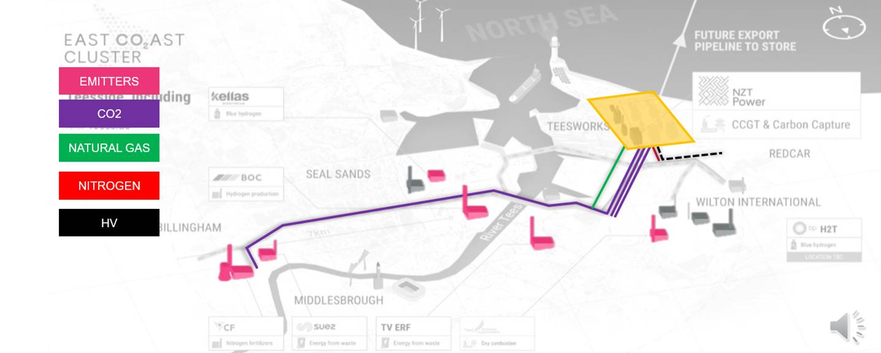

Programme
Based on historical and current knowledge and market intelligence Costain would like you to register interest in the following activity/activities:
Discipline | Activity | ITT Issue Date | Award Date | Start Date (mob) | End Date
275kv HV Cable | Power Plant to Tod Point Transformer Station:  Engineering, Procurement, Construction and Commissioning (EPCC) | July 2024 | Oct 2024 | Oct 2024 | Dec 2026
Civils (Enabling) | Incl Site Establishment, Laydown Areas, Access Roads, Services and Utilities, Security Fences, Car Parks, Grading and Welfare Establishment | Dec 2024 | Apr 2025 | May 2025 | Oct 2025
Civils (Major) | Pipeline and Above Ground Installations (AGIs) Foundations incl Piling, Roads, Rail Crossing, Culverts and Open Cut crossing incl pipe tunnels. | Nov 2024 | Mar 2025 | Apr 2025 | Aug 2025
Civils | HV Cable Route incl Foundations, Cable Pits and Jointing Pits. | Nov 2024 | Mar 2025 | Mar 2025 | Mar 2026
Structural | Steelwork Supply, Fabrication, Coating and Installation for Pipebridges, Pipe Supports, Equipment Supports, Step Overs, Grating, Handrail, Road Barriers | Feb 2025 | Aug 2025 | Aug 2025 | Nov 2026
Natural Gas Pipeline | 1.5 km of Buried 24” Pipeline incl AGI’s, Tie-In’s and Mechanical Equipment:  Fabrication, Installation and Commissioning (both Civils and Pipeline). | Jun 2025 | Nov 2025 | Apr 2026 | Nov 2026
CO2 and Nitrogen Pipelines | 8kms of Above ground and Tees Tunnel 22” pipeline (CO2) incl Isolation Joints and Mechanical Equipment:  Installation and Commissioning  (Size of Nitrogen Pipeline tbc.) | Mar 2025 | Sep 2025 | Sep 2025 | Apr 2027
Electrical, Instrumentation and Controls | Fibre Optic Cables, Electrical Cables, F&G System and ICSS assistance:  Installation and Commissioning | Jun 2025 | Dec 2025 | Dec 2025 | Mar 2027
Unless noted in the above table, materials will be Free Issue from NZT and NEP except for sundry items which will be defined later.

Facilities Contract Strategy

Procurement Drivers
The IJV partners are committed to generating meaningful economic benefits for the UK by working with the local industry and world-class partners to ensure a successful delivery of this First of a Kind project. While being committed to the goal of no accidents, no harm to people and no damage to the environment; the IJV’s want its suppliers to strive for sustainability in their supply chain, and innovation and excellence in their delivery. The Procurement Process are to be completed with due diligence to ensure the right Contractors are selected to deliver the Project and IJV local content requirements.
All scopes will be contracted directly with the IJVs on a bespoke IJV form of contract.

Procurement Process
Step 1 – Expression of Interest
Step 2 – Pre-Qualification Questionnaire / Request for Information
Step 3 – Invitation to Tender (ITT)
Step 4 – Contractor Shortlist and Final Negotiations
Step 5 – Contract Award

Confirmation if Interest
Interested Suppliers must provide the information requested within the EOI Supplier Questionnaire to be considered for further assessment.
Please ensure your EOI return form and EOI Supplier Questionnaire is received to us no later than COB 17 May 2024.
Any queries relating to this EOI should be emailed to: NZT.NEP@costain.com
The submission of your EOI shall be sent via email to NZT.NEP@costain.com

EXPRESSION OF INTEREST - RETURN
TO: Costain Limited
Costain House, 1500 Aviator Way
Manchester Business Park
Manchester, M22 5TG
Date: __________________________
For the attention of: Andrew Dickson (NZT.NEP@costain.com)
Dear Sirs,
Project Title: NZT NEP OSBL Project
RE: Expression of Interest
We acknowledge receipt of Costain Expression of Interest Letter for the above project.
1. (a) We confirm that we __________________________________________ (company name) are interested in the above project and would like to be considered to provide a Tender for the following packages:
Package | Interested (Y/N)
Enabling Civils (site establishment, laydown areas etc)
NOTE – The EXPRESSION OF INTEREST- SUPPLIER EOI QUESTIONNAIRE to be submitted along with this EOI RETURN.
(b) We are not interested in the above project for the following reasons:
.....................................................................................
*Delete (a) or (b) as applicable.
Our representative who should be contacted in relation to further correspondence of this project is as follows:
__________________________________ whose title is ___________________________
Telephone No. ______________________ email address__________________________
Yours faithfully,
For and on behalf of
Signed: .....................................................................................

Position: .....................................................................................

8 SUPPLY CHAIN QUESTIONNAIRE

Introduction

This document is intended to help us assess suitability of interested suppliers to progress to a formal PQQ Process for the NZT NEP OSBL Project.

Please read the following instructions carefully:

Completion Instructions

PLEASE COMPLETE THE QUESTIONNAIRE AND RETURN WITH THE EOI SUBMISSION.

All questions must be addressed – please do not leave any blanks. Please use the words NONE or NOT APPLICABLE (N/A) where applicable. Any unanswered or blank questions may result in your interest not being accepted.

Except where requested, answers submitted MUST apply specifically to the Company named at the beginning of Section 1 and must be exclusive to the activities of Parent, Associate, Group or Subsidiary Companies.

Any information constituting Personal Data as defined in the General Data Protection regulation shall be treated and safeguarded in accordance with the requirements of GDPR and any subsequent amendment or re-enactment thereof.

A copy of the Costain Data Protection Policy is available upon request.

The processing of your personal data is necessary for the administration of the business relationship.

PLEASE RETURN QUESTIONNAIRE TO: NZT.NEP@costain.com

1.0 GENERAL DETAILS
  - Name of Company:

1.2 Company Registered Address:

1.3 Company Trading Address (if different):

1.4 Telephone No.:

1.5 Contact Name:

1.6 Position held within your organisation:

1.7 Email Address:

1.8 Company Website Address:
1.9 Is your Engineering / Manufacturing / Fabrication activity carried out at the same location? | Yes No
1.10 Please advise if different from above:

1.11 Is your company a Public/Private Company? | Public Private
1.12 Name and address of Parent Company or Group/Affiliates, if any:

1.13 Please advise:
Company Registration No.

1.14 Year Company established?  1.15 Has your company previously worked for Costain or bp? If yes, please advise of recent projects and dates.  1.16 Please provide relevant experience working on live Oil & Gas or Tier 1 COMAH Sites. Including: | Yes No  Project Client Year  Project Client Year
1.17 We would like to understand your capacity to support the project and would like you to Indicate numbers of PERMANENT staff in the following categories:
a) Office based staff (admin, engineering, procurement, etc)
b) Site / operations staff
c) Fabrication staff

1.18 Indicate which key trades are appropriate to your normal business:  - Supplier preferred remuneration model.  - Please indicate if you are utilising NAECI/CIJC arrangements | Minor Civils  Enabling works (Specify)  Other (Specify)  Lumpsum  Target Cost  Reimbursable  Re-measurable (Schedule of Rates)  Other (Specify)  Yes No  Other  (Specify below)
2.0 FINANCIAL DETAILS
Please provide details of: | Please use numerical values only
2.1 Annual Turnover & Profit | Last Year (2023)  This Year (2024)  Forecast Year (2025)
2.2 Maximum tender limit

2.3 Order book value

2.4 Any Administration Order that you have been subject to during the last five (5) years.

2.5 Are there any current or pending actions against your company by the Inland Revenue? If yes, please provide details of the complaint and the outcome. | Yes No
3.0 DETAILS OF PRODUCTS & SERVICES
3.1 Please specify major subcontracted elements of the works you deliver.
4.0 PREMISES
4.1 Please give details of your fabrication Facilities / Design Office etc., i.e. size of workshops, area covered by offices etc:

4.2 State maximum weights/diameters of handling within workshop, e.g. cranage capacities, access to workshops (if applicable):
5.0 ENGINEERING FACILITIES
5.1 Do you have in-house engineering capabilities? | Yes No
If yes, give brief details:

If no, do you outsource design work? State which design organisation you use.

5.2 Can you provide your own designs from customers’ data? | Yes No
5.3 What version(s) of CAD, if any, do you operate?
5.4 Do you have the facilities for 3D and rendered drawings? | Yes No
5.5 Do you have a computerised production programming facility? | Yes No
6.0 QUALITY ASSURANCE AND QUALITY
CONTROL
6.1 Does your Company hold the following:
ISO 9001 | Expiry No
ISO 14001 | Expiry No
OHSAS 18001 | ISO 45001 | Expiry No
ISO 27001 | Expiry No
If any answer is no….

6.2 Does your Company have a specific Quality Document and Process to set out quality practices? | Yes No
7.0 SAFETY, HEALTH & ENVIRONMENT  7.1 Does your company have a combined or separate Safety, Health and Environmental Policy? | Yes No
7.2 Has your company or Group been served any notices or prosecutions in the last 5 years for any SHE related offences. If yes, please provide details of the complaint and the outcome. | Yes No
8.0 CAPABILITY
8.0 Capability for this type of work – Please provide one example from the last 3 years of similar works provided.

- Location

- Scope

- Value

- Duration

All the information provided in this document is complete, true and correct and I, the undersigned, am authorised by the relevant person in my organisation to provide this information. I understand that false information could result in the termination of any future contact:

Signed:
Print Name:
Company:
Position:
Date:

Costain Comments:

Signature & Date:

Print Name:

Company Name:
EOI acceptable to progress to next stage(Y/N):
EOI Approval Date:

